| C:\Users\Robert\Desktop\Dec 2015 Newsletter\Comp Hike Pics New folder\P1030020.jpg  TROOP 314 NEWS bslgoclr**June 2017 AD** For More Pictures, calendar and past newsletter copies Troop 314 website, URL is: <http://www.troop314ocbsa.scoutlander.com> | IN THIS ISSUE:   * Troop Events of last month * Troop Calendar * http://orangefrontier.ocbsa.org/sites/default/files/OFDpatch.gif Sasquatch’s Tips for Scouts * Upcoming Events * **+And** **Much More - Newsletter contains numerous links to click for more information!**     **Contact Editor at: t314news@live.com** |
| --- | --- |
| *BSA Troop 314 - Orange Frontier District*  *Westminster, (Midway City) C**alifornia* | *Sponsored by: Albert E. Schwab*  *American Legion Post 555*  (Midway City) |

**Events Completed for Troop 314 in May**

* **13-May Tower build and operation @ Scout O Rama**
* **15-May Andrew Martel   
  Eagle Court of Honor**
* **Memorial Day / Poppy Hand out Weekend**

**Scout O Rama 2017**

We almost all got out to Oak Canyon on Friday the 12th and though had a kind of late start – we built the Troop 314 observation / climbing tower in what had to be record time – and it was not upside-down and was reasonably square.

That Saturday we ran some 72 scouts and scout family members up and down the tower safely.

Mr. M has the pictures, but is off on his Mount Whitney Hike this week.

**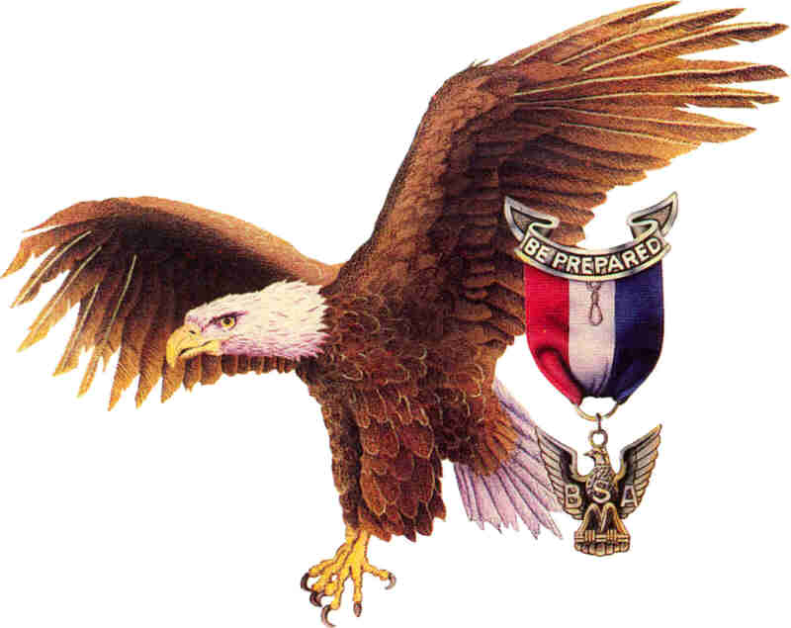Eagle COH**

It took a while and two scout troops (314 and 127), but Andrew Martel finally has his Eagle rank and his Court of Honor**.**

On Monday May 15th the Pearson’s and the Marubayshi’s attended an Eagle Court of Honor in Corona. Mr. M helped officiate the event as part of Trail to Eagle and did a great job, as ever.

**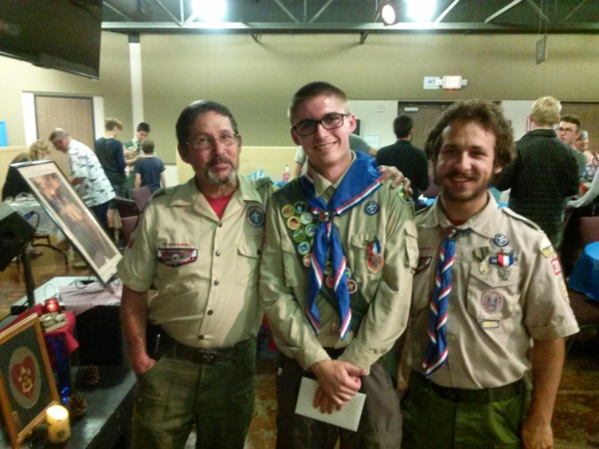**

**Three Eagles**

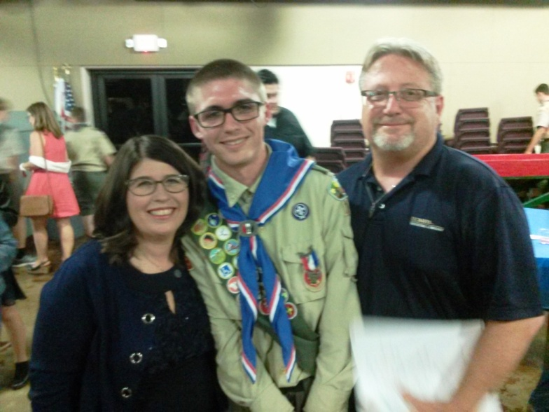

**Eagle with proud parents.**

sq-rope

# Troop 314

# PLC Meeting Minutes

June 5, 2017

Call to order

Called to order the regular PLC meeting of Troop 314 at 6:49 p.m. on June 5, 2017 at Bolsa Chica Park in Westminster.

Roll call

The following Scouts were present: Martin (SPL), Ethan (Scribe), Christian (ASPL), Owen (Troop Guide)

Approval of minutes from last meeting

Minutes from last meeting (May 2nd) was approved by Martin and minutes were emailed to all Troop 314 members.

New business

1. Discuss events on the annual calendar

* June 13th: Elections and Summer camp talk
* June 17th: Hike Eaton Canyon
* June 20th: ILST 6:00 p.m. – 8:00 p.m.
* June 23rd – 25th : Gold Camp
* June 27th : Court of Honor

(Owen is MC) - Potluck

* July 8th: Homework Burn @ Bolsa Chica State Beach 7pm – 10pm
* July 24th – 28th : Twilight Camp

Adjournment

Martin adjourned the meeting at 7:41 p.m.

Minutes submitted by: Ethan T.

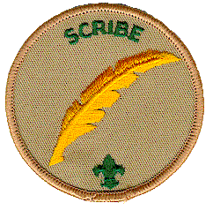Minutes approved by: Martin L.

* Troop Scribe, ***Ethan T.***

**sq-rope**

**Contact Information Link**

Please update your contact information as needed.

<https://docs.google.com/spreadsheets/d/1ALgJqX-iwYHBrTZ8xf7AuGKqIJv6FxyLLXZP3NjuVFk/edit?usp=sharing>

sq-rope

****

**Activities Sign Up Link**

Please use this shared document to sign up for upcoming activities.

<https://docs.google.com/spreadsheets/d/176b23wuQdDTa2E1A_38IzIjnT7WvTg0HjSre9dIa1e8/edit?usp=sharing>

sq-rope

**Troop Calendar Link**

Use this link to see the Troop calendar.

<https://docs.google.com/document/d/1Lls71fa5hxe2paPHrVYN13xQsnYCEsTVVDbOwvurMVo/edit?usp=sharing>

**sq-rope**

**New Rank Advancement requirements Link**.

Here is a link to the document explaining the changes:

[**http://www.scouting.org/filestore/pdf/2016BoyScoutRequirements\_8.14.2015.pdf**](http://www.scouting.org/filestore/pdf/2016BoyScoutRequirements_8.14.2015.pdf)

**sq-rope**

**Scout in Charge/Scout Leader Planning Sheet**

This is the link to the planning document.

<http://troopleader.org/wp-content/uploads/2016/03/512-505_16_Wksht_WEB.pdf>

Please plan to use it when you are the assigned Scout in Charge of an Activity.

**sq-rope**

**TROOP 314 WEBSITE URL is:**

[**www.troop314ocbsa.scoutlander.com**](http://www.troop314ocbsa.scoutlander.com)



**sq-rope**

**Orange Frontier District Website Link**

[**http://orangefrontier.ocbsa.org/**](http://orangefrontier.ocbsa.org/)

**sq-rope**

**Troop 314 Leadership**

* Senior Patrol Leader: Martin L.
* Assistant Senior Patrol Leader: Christian D.
* Scribe: Ethan T.
* Webmaster: Owen M.
* Den Chief - Christian D.
* Chaplin’s Aid – Diego M.

**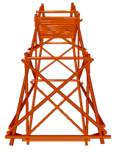**

**Get Your Calendars and mark these dates!**

**T314 EVENTS FOR June 2017**

**5th Patrol Leadership Council  
The following people were present: Martin (SPL), Ethan (Scribe)**

**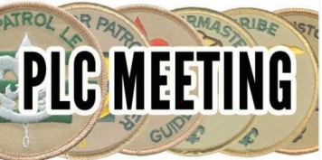**

**8th Orange Frontier District Scouters’ Roundtable**

**7 PM at LDS Church 4000 Orange Ave., Anaheim (2nd Thursday each month)**

**13th Regular Troop 314 Meeting American Legion Post 555**

**Starting at 6:30PM**

* **Elections**

**14th Flag Day**

**15th OA Meeting Night oa_logo_16x16**

**17th Hike to Eaton Canyon**

**20th Regular Troop 314 Meeting American Legion Post 555**

**Starting at 6:30PM**

* **ILST**

**23rd to 25th Placer Pete’s Gold Camp @ Camp Williams.**

**27th Court of Honor**

**American Legion Post 555**

**Starting at 6:30PM **

**sq-rope**

**Troop 314 Meeting Notes**

* **First meeting of Month is time for Committee Chair Parents Meeting.**
* **The Second Tuesday is usual time for Scoutmaster Conferences.**
* **The Third Tuesday meeting includes Board of Reviews for Rank Advancement when not a COH.**
* **Fourth Tuesday could be for Patrol meetings if you are able to get the Scoutmaster to come early or close late.**
* **No meetings are usually held on 5th Tuesday. These are saved for Fundraisers, or special meetings at interesting locations.**

**Court of Honor is** held 4 times a year, every 3 months – usually the last Scout meeting of month (except December). In **March** and **September COH** Scouts are honored for their rank advancements with a candle lighting ceremony and parents are given pins. In **June** and **December**, **our COH** does not have candles and rank advancement pins for parents, but we add a potluck dinner in June – (Optional potluck in Dec.).

**UPCOMING EVENTS**

****

**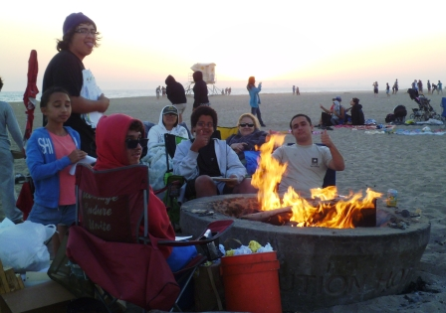July 8th Beach Party – Home Work Burn**

**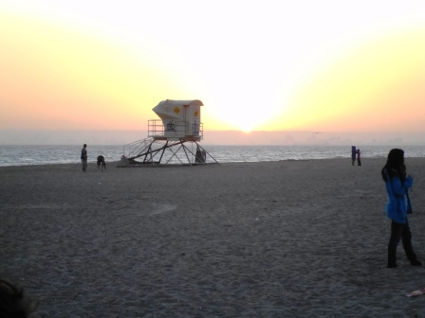**

**July 24th – 28th**

**Cub Scout Twilight Camp (Service Opportunity)**

|  |  |
| --- | --- |
| |  | | --- | |  | |

**blue_line_star.gif**

**Hights Home Fire**

**– Go Fund me page Link:**

[**https://www.gofundme.com/the-hights-relief-fund?ssid=835937610&pos=3**](https://www.gofundme.com/the-hights-relief-fund?ssid=835937610&pos=3)

**THANK YOU TO ALL WHO DONATED!!!!**

**blue_line_star.gif**

**OCBSA Dedicated Climbing Website**

The Orange County Council Climbing Team has created a NEW website to keep everyone informed about training opportunities, climbing events, help needed, etc.   
  
The list of people is over 900 Scouters! The website can be found under the 'Camping' tab of the Orange County Council website:

http://www.ocbsa.org/

OR

It can be found directly at this address:

http://climbing.ocbsa.org/

***sq-rope***

**The Outdoor Code**

***As an American, I will do my best to -***

***Be clean in my outdoor manners.***

***Be careful with fire.***

***Be considerate in the outdoors.***

***and***

***Be conservation minded***



## Scout Oath

***On my honor, I will do my best   
To do my duty to God and my country and to obey the Scout Law;***

***To help other people at all times;***

***To keep myself physically strong, mentally awake and morally straight.***

sq-rope

****

**Personal Mess kits:**

**Troop 314 is Camping Green!**

Personal Mess kits are used on 99.889 % of Troop campouts – If in doubt, buy one and bring yours!

**sq-rope**

**The Troop can help you do something you always wanted to do!**

**Scouts – You have the Power to make some serious fun happen!**

**Just talk to Activities Chair or Scoutmaster or your SPL to get the ball rolling on one of these great activities, and while you are at it - step up to be Scout in Charge. The Troop Committee will hook you up with the adults and resources to make it happen!**

***Activities are only limited by your imagination:***

**Archery**

**Deep Sea Fishing** - boat Trip

**Ocean fishing**

**Beach party /** Annual Homework Burn Bonfire (June)

**Bowling**

**Go Cart Racing** (Family)

**Hiking Trips**

**Backpacking -** Hike in and out.

Camp in wilderness.

**Snow Day**.

**Ski / Snowboard Trip**

**Laser Tag** (Family)

**Air Soft Games** (Family)

**Paint Ball / Airsoft** (Family)

**Shooting Range**

**BLM land / Calico Ghost Town - Desert Shoot –** Rifles / Pistols (Family event)

**Rock climbing** - Indoor walls or natural climbs work - we have BSA Climb Instructors and our own climb gear!

**Attend a Baseball Game**

**Gold Prospecting /** Gold Camp

**Swim –** Pool / Ocean Laguna Beach Trip

**Scuba Instruction**

**Snorkeling / Beach Trip**

**White water rafting**

**Canoe River Trip**

**Annual Mistletoe Trip  
Annual Homework Burn!**

Usually June at Bolsa Chica State beach

**Kayaking**

**Picnic / BBQ**

**blue_line_star.gif**

**Order of the Arrow**

**Wiatava Lodge (#39) Santee Chapter**

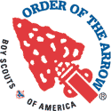

OA Santee Chapter Meeting are held on every 3rd Thursday of the month at 7:00pm at Holy Cross Lutheran Church oa_logo_16x16.

<http://www.ocbsa.org/resources/order-of-the-arrow/>

**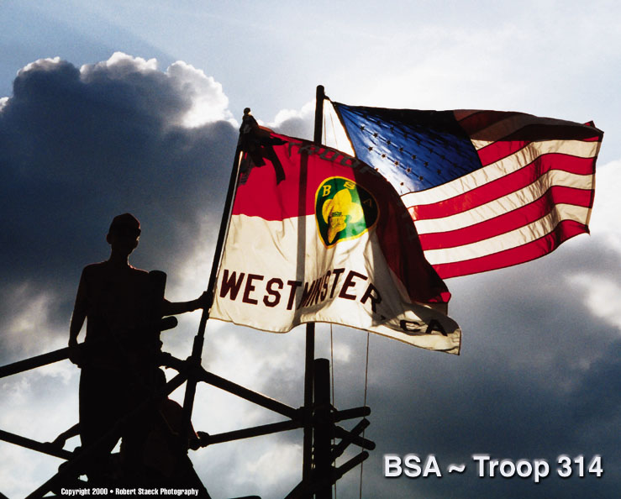**

**sq-rope**

****

**New Advancement & Blue Card Procedures**

The Scout Shop will not be collecting Merit Badge Blue Cards to sell Merit Badges. The MB Blue Card tears into three parts. One part is to remain with the applicant, one part is to remain with the counselor, and one part is to remain with the unit.   
  
The only item needed to present at the Scout Shop to purchase Merit Badges and Rank Advancement is a printed and completed copy of the **unit advancement report**, as we are doing now.

The Scout Shop will no longer require that a copy of the advancement report be turned in. A unit will now only need to present one copy of the Internet Advancement Report to purchase rank and Merit Badge Advancements for verification. Once the Scout Shop has reviewed the report, it will be returned back to the unit.   
  
Eagle Scout Advancement reports will still need to be turned in to the registration department for processing, until such time as the online system can accommodate Eagle Scout advancements in the same way other advancements are accommodated.  
**blue_line_star.gif**

**Hall Use at American Legion**

**Post 555**

If you would like to have an event at the Post – from a training day, a car wash or an Eagle Court of Honor, please e-mail Steve Scukanec to confirm the hall is available and to make reservations. **scukanecbsa@hotmail.com**

Steve Scukanec is our troop Chartered Organization Representative.

**blue_line_star.gif**

**Chaplain’s   
Wisdom of the month:**

### *jl-chapl Isaiah 40:31*

### ***But those who trust in the Lord will find new strength. They will soar high on wings like eagles. They will run and not grow weary. They will walk and not faint.***

***sq-rope***

**JOKES JOKES JOKES**

Q: Why did the tree grow?

A: Because he wanted to leave!

Q: How did the man fall out of the tree?

A: It was a windy day and he slipped.

Q: What do you call a doctor with no eyes?

A: Blind.

Roses are red.

Violets are blue.

Sunflowers are yellow.

These are all gardening facts.

Q: What did the snail say when the bird sang him a song?

A: Nothing. Gastropods have no sensory organs for hearing.

Q: What is Santa’s favorite color?

A: Blue.

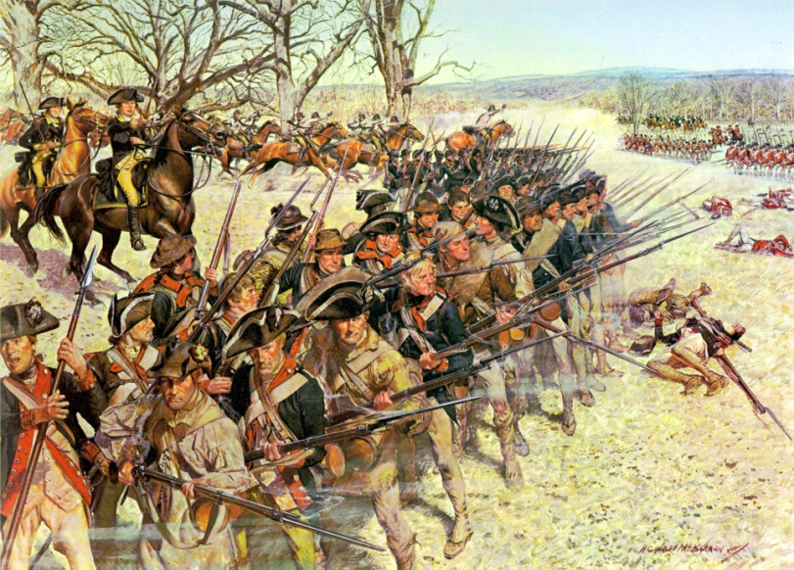

**It was not the Declaration of Independence that gave us freedom but the Continental Army.**

**America was born from conflict, delivered by soldiers willing to pay with their blood the tremendous cost of freedom.”**

* Mr. Leif Babin, former Navy SEAL officer who deployed three times to Iraq.

**“Never do for a boy what a boy can do for himself.” - Lord Baden Powell**

**TROOP 314:**

**TOWER ABOVE THE REST!**

To get a copy of the most current Newsletter or for more information about Troop 314

send me a note at T314news@live.com -Thanks, Mr. Pearson

**The Troop 314 website, URL is:** http://www.troop314ocbsa.scoutlander.com

**Troop 314 Scoutmaster: Vu Tran** vtran314@yahoo.com



Troop 314 Tower Picture (paint)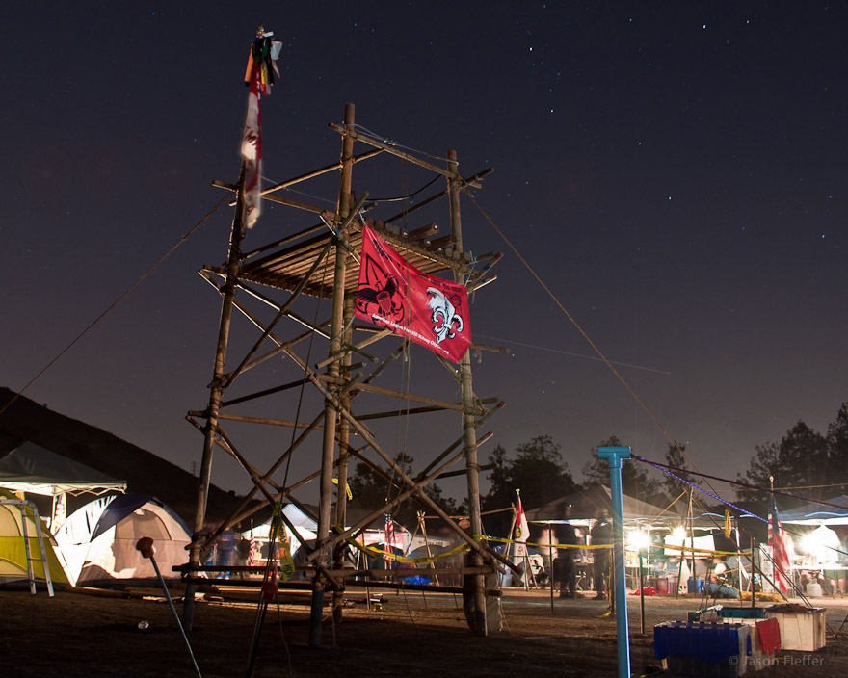Troop 314 Tower Picture (paint)